Rhombus-Base Prism
# Source: AI Source: Provided by: [Data Path: Persons Table -> ID Column: 1, Name_En Column: Motasem Essam] -> From: [ChatGPT] on [7/25/2026]
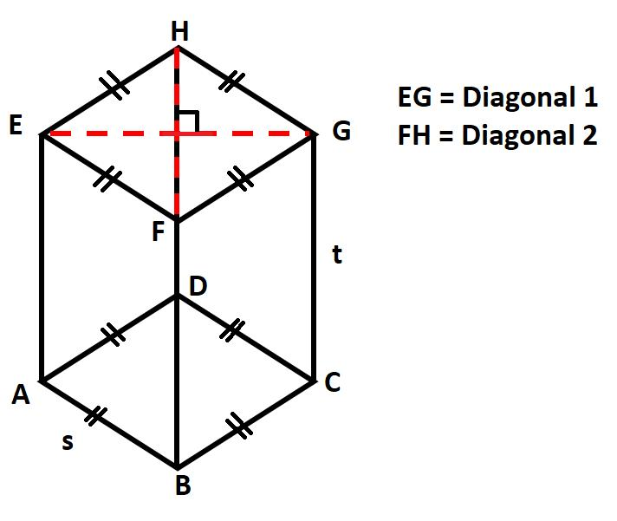
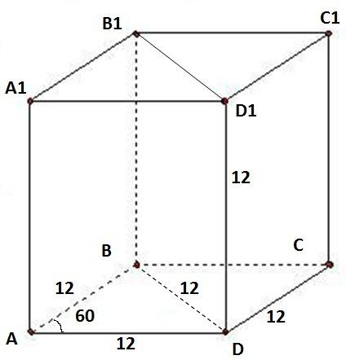
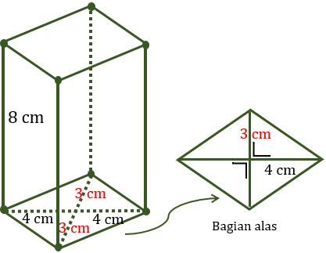

Definition
# Source: AI Source: Provided by: [Data Path: Persons Table -> ID Column: 1, Name_En Column: Motasem Essam] -> From: [ChatGPT] on [7/25/2026]
A rhombus-base prism is a prism whose two bases are congruent, parallel rhombuses connected by four lateral faces.
A rhombus is a quadrilateral with four equal sides. Its opposite angles are equal, and its diagonals intersect at right angles and bisect each other.
A rhombus-base prism has:
- 2 rhombus-shaped bases.
- 4 lateral faces.
- 6 faces in total.
- 12 edges.
- 8 vertices.
The lateral faces are rectangles when the prism is a right prism and parallelograms when it is an oblique prism.

Simple Definition
# Source: AI Source: Provided by: [Data Path: Persons Table -> ID Column: 1, Name_En Column: Motasem Essam] -> From: [ChatGPT] on [7/25/2026]
A rhombus-base prism is a 3D solid with two matching rhombus-shaped ends joined by four side faces.
Imagine taking a flat rhombus and extending it in a straight direction to create a solid with depth.

Classification Tree
# Source: AI Source: Provided by: [Data Path: Persons Table -> ID Column: 1, Name_En Column: Motasem Essam] -> From: [ChatGPT] on [7/25/2026]
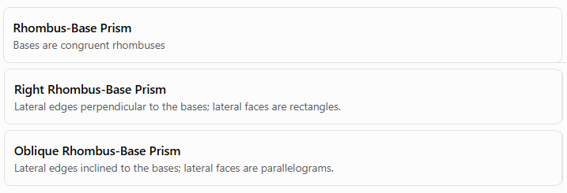
Rhombus-Base Prism
Bases are congruent rhombuses
Right Rhombus-Base Prism
Lateral edges perpendicular to the bases; lateral faces are rectangles.
Oblique Rhombus-Base Prism
Lateral edges inclined to the bases; lateral faces are parallelograms.
A rhombus-base prism is classified by the shape of its bases. The right or oblique classification describes how the prism extends between those bases.

Key Characteristics
# Source: AI Source: Provided by: [Data Path: Persons Table -> ID Column: 1, Name_En Column: Motasem Essam] -> From: [ChatGPT] on [7/25/2026]
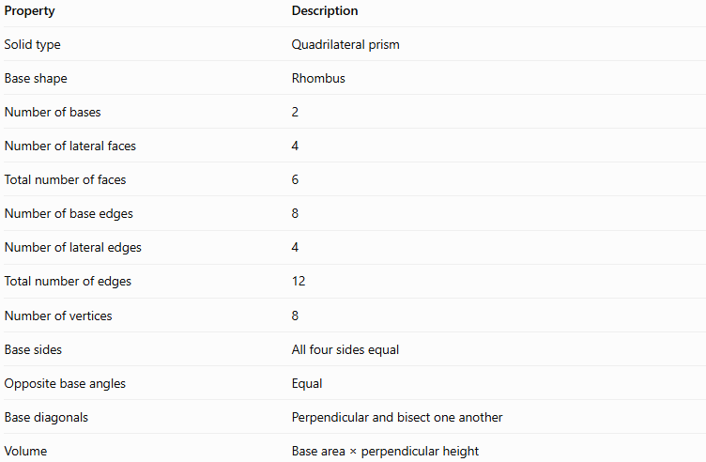
Property | Description
Solid type | Quadrilateral prism
Base shape | Rhombus
Number of bases | 2
Number of lateral faces | 4
Total number of faces | 6
Number of base edges | 8
Number of lateral edges | 4
Total number of edges | 12
Number of vertices | 8
Base sides | All four sides equal
Opposite base angles | Equal
Base diagonals | Perpendicular and bisect one another
Volume | Base area × perpendicular height

Geometric Representation
# Source: AI Source: Provided by: [Data Path: Persons Table -> ID Column: 1, Name_En Column: Motasem Essam] -> From: [ChatGPT] on [7/25/2026]
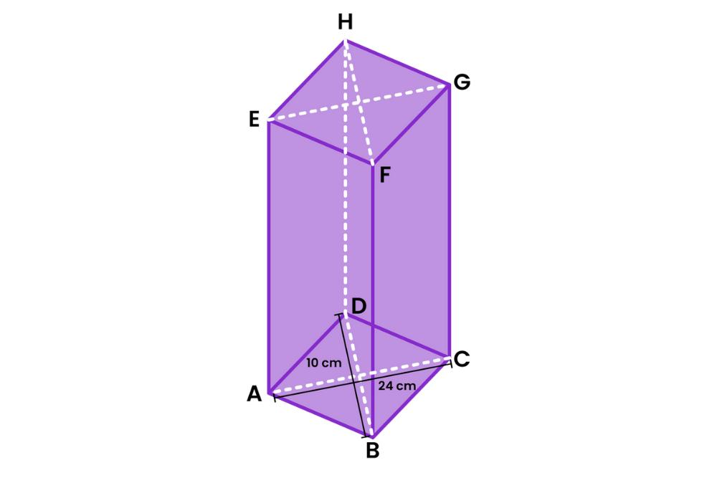
The main parts of a rhombus-base prism are:
- Base faces: The two congruent rhombuses at opposite ends.
- Lateral faces: The four faces joining corresponding sides of the bases.
- Base edges: The edges surrounding the two rhombus bases.
- Lateral edges: The four edges connecting corresponding vertices of the bases.
- Vertices: The eight corner points of the solid.
- Height: The perpendicular distance between the two base planes. For an oblique prism, this is not generally the length of a lateral edge.

Mathematical Representations and Formulas
# Source: AI Source: Provided by: [Data Path: Persons Table -> ID Column: 1, Name_En Column: Motasem Essam] -> From: [ChatGPT] on [7/25/2026]
Let:
- $a$ = side length of the rhombus.
- $d_{1}$ and $d_{2}$ = lengths of the rhombus diagonals.
- $B$ = area of one base.
- $p$ = perimeter of the base.
- $h$ = perpendicular height of the prism.
- $A_{L}$ = lateral surface area.
- $A_{T}$ = total surface area.
- $V$ = volume.

A. Base area
# Source: AI Source: Provided by: [Data Path: Persons Table -> ID Column: 1, Name_En Column: Motasem Essam] -> From: [ChatGPT] on [7/25/2026]
The area of a rhombus can be calculated using its diagonals:
$$B=\frac{1}{2}d_{1}d_{2}$$
Alternatively, if $a$ is the side length and $θ$ is an interior angle:
$$B=a^{2}\sin{θ}$$

B. Base perimeter
# Source: AI Source: Provided by: [Data Path: Persons Table -> ID Column: 1, Name_En Column: Motasem Essam] -> From: [ChatGPT] on [7/25/2026]
Since all four sides of a rhombus are equal:
$$p=4a$$

C. Volume
# Source: AI Source: Provided by: [Data Path: Persons Table -> ID Column: 1, Name_En Column: Motasem Essam] -> From: [ChatGPT] on [7/25/2026]
The volume of any prism is the base area multiplied by the perpendicular height:
$$\boxed{V=Bh}$$
For a rhombus-base prism:
$$\boxed{V=\frac{1}{2}d_{1}d_{2}h}$$
This formula applies to both right and oblique prisms, provided $h$ is the perpendicular distance between the bases.

D. Lateral surface area
# Source: AI Source: Provided by: [Data Path: Persons Table -> ID Column: 1, Name_En Column: Motasem Essam] -> From: [ChatGPT] on [7/25/2026]
For a right rhombus-base prism, all four lateral faces are rectangles. Therefore:
$$A_{L}=ph$$
Since $p=4a$:
$$\boxed{A_{L}=4ah}$$
For an oblique rhombus-base prism, the lateral faces are parallelograms, and the lateral surface area must be calculated from the areas of those faces. In general, it cannot be found simply by multiplying the base perimeter by the perpendicular height.

E. Total surface area
# Source: AI Source: Provided by: [Data Path: Persons Table -> ID Column: 1, Name_En Column: Motasem Essam] -> From: [ChatGPT] on [7/25/2026]
The total surface area is the sum of the lateral surface area and the areas of the two bases:
$$A_{T}=A_{L}+2B$$
For a right rhombus-base prism:
$$\boxed{A_{T}=4ah+d_{1}d_{2}}$$
Here, $d_{1}d_{2}$ represents the combined area of the two rhombus bases.

Worked Examples
# Source: AI Source: Provided by: [Data Path: Persons Table -> ID Column: 1, Name_En Column: Motasem Essam] -> From: [ChatGPT] on [7/25/2026]
Example 1: Counting faces, edges, and vertices
Problem: How many faces, edges, and vertices does a rhombus-base prism have?
Solution:
A rhombus is a quadrilateral, so $n=4$.
For an $n$-gonal prism:
$$F=n+2, E=3n, V=2n$$
Substituting $n=4$:
- Faces: $F=4+2=6$
- Edges: $E=3\left(4\right)=12$
- Vertices: $V=2\left(4\right)=8$
Answer: 6 faces, 12 edges, and 8 vertices.
Example 2: Calculating the volume
Problem: A rhombus-base prism has base diagonals of $6\text{ cm}$ and $8\text{ cm}$, and a perpendicular height of $10\text{ cm}$. Find its volume.
Step 1: Calculate the base area.
$$B=\frac{12}{\left(6\right)}\left(8\right)=24{\text{ cm}}^{2}$$
Step 2: Calculate the volume.
$$V=Bh=24\left(10\right)$$
$$\boxed{V=240{\text{ cm}}^{3}}$$
Example 3: Calculating the lateral and total surface areas
Problem: A right rhombus-base prism has a rhombus base with diagonals of $6\text{ cm}$ and $8\text{ cm}$, and a height of $12\text{ cm}$. Find its lateral and total surface areas.
Step 1: Find the side length.
The diagonals of a rhombus bisect each other at right angles. Thus, half the diagonals are $3\text{ cm}$ and $4\text{ cm}$.
Using the Pythagorean theorem:
$$a=\sqrt{3^{2}+4^{2}}=5\text{ cm}$$
Step 2: Find the lateral surface area.
$$A_{L}=4ah=4\left(5\right)\left(12\right)$$
$$\boxed{A_{L}=240{\text{ cm}}^{2}}$$
Step 3: Find the total surface area.
The base area is $24{\text{ cm}}^{2}$.
$$A_{T}=A_{L}+2B$$
$$A_{T}=240+2\left(24\right)$$
$$\boxed{A_{T}=288{\text{ cm}}^{2}}$$
Example 4: Verifying Euler’s formula
Problem: Verify Euler’s formula for a rhombus-base prism.
Euler’s formula for a convex polyhedron is:
$$V-E+F=2$$
Substitute $V=8$, $E=12$, and $F=6$:
$$8-12+6=2$$
$$\boxed{2=2}$$
Euler’s formula is satisfied.

Comparison with Other Quadrilateral Prisms
# Source: AI Source: Provided by: [Data Path: Persons Table -> ID Column: 1, Name_En Column: Motasem Essam] -> From: [ChatGPT] on [7/25/2026]
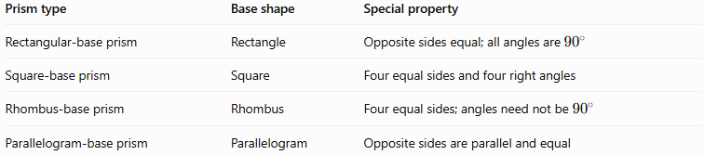
Prism type | Base shape | Special property
Rectangular-base prism | Rectangle | Opposite sides equal; all angles are ${90}^{∘}$
Square-base prism | Square | Four equal sides and four right angles
Rhombus-base prism | Rhombus | Four equal sides; angles need not be ${90}^{∘}$
Parallelogram-base prism | Parallelogram | Opposite sides are parallel and equal
A square is a special type of rhombus, so a square-base prism also qualifies as a rhombus-base prism. However, a rhombus-base prism does not necessarily have square bases.

Constructing Rhombus-Base Prism in Solid Geometry

Instruments Used
# Source: AI Source: Provided by: [Data Path: Persons Table -> ID Column: 1, Name_En Column: Motasem Essam] -> From: [ChatGPT] on [7/25/2026]
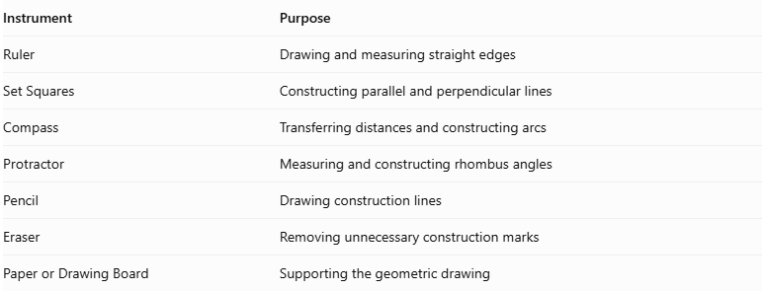
Instrument | Purpose
Ruler | Drawing and measuring straight edges
Set Squares | Constructing parallel and perpendicular lines
Compass | Transferring distances and constructing arcs
Protractor | Measuring and constructing rhombus angles
Pencil | Drawing construction lines
Eraser | Removing unnecessary construction marks
Paper or Drawing Board | Supporting the geometric drawing

Construction Procedures

Isometric Construction
# Source: AI Source: Provided by: [Data Path: Persons Table -> ID Column: 1, Name_En Column: Motasem Essam] -> From: [ChatGPT] on [7/25/2026]
- Determine the side length and interior angles of the rhombus base.
- Determine the required prism height.
- Draw the first rhombus-shaped base using a ruler and protractor.
- Represent the rhombus in the selected isometric drawing orientation.
- From each base vertex, draw a lateral edge representing the prism height.
- Ensure that all lateral edges are equal and parallel.
- Draw the second congruent rhombus at the opposite ends of the lateral edges.
- Connect the corresponding vertices to complete the four lateral faces.
- Distinguish visible and hidden edges.
- Refine the drawing and label its dimensions.
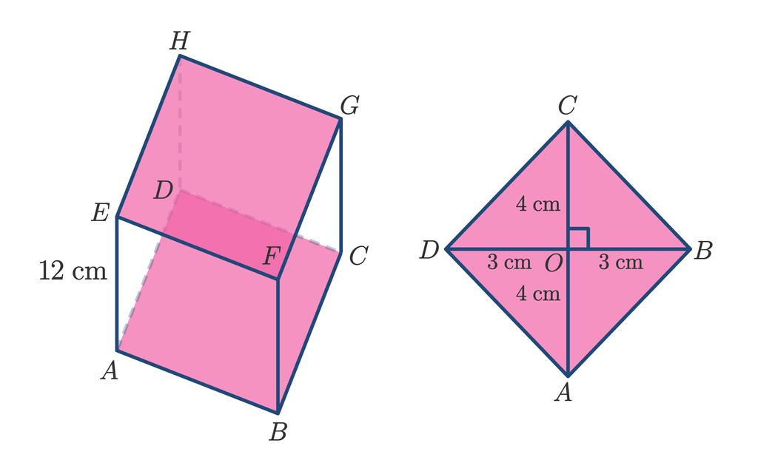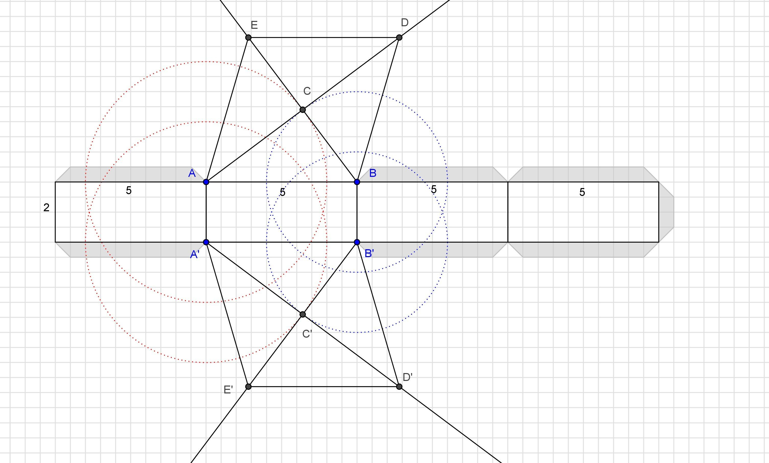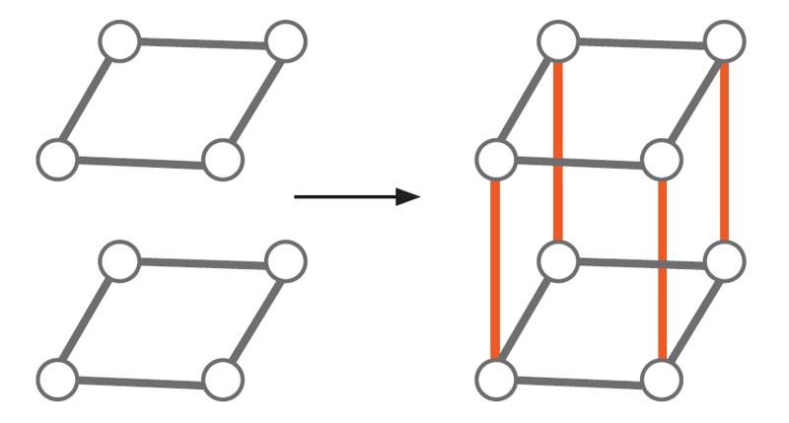

Orthographic Construction
# Source: AI Source: Provided by: [Data Path: Persons Table -> ID Column: 1, Name_En Column: Motasem Essam] -> From: [ChatGPT] on [7/25/2026]
- Determine the rhombus side length, base angles, and prism height.
- Draw the top view as a rhombus.
- Draw the front view according to the selected viewing direction.
- Draw the side view showing the corresponding base dimension and prism height.
- Align the views according to the selected orthographic projection convention.
- Ensure that corresponding edges and dimensions are consistent.
- Add visible and hidden lines where necessary.
- Label the base dimensions and height.

Face-Based Construction
# Source: AI Source: Provided by: [Data Path: Persons Table -> ID Column: 1, Name_En Column: Motasem Essam] -> From: [ChatGPT] on [7/25/2026]
- Draw the first rhombus-shaped base.
- Determine the required prism height.
- Draw a second congruent rhombus at the required distance.
- Keep both bases parallel.
- Connect the corresponding vertices of the two rhombi.
- Complete the four lateral faces.
- For a right prism, ensure that the connecting edges are perpendicular to the base planes.
- Refine the edges and visible surfaces.

Edge-Based Construction
# Source: AI Source: Provided by: [Data Path: Persons Table -> ID Column: 1, Name_En Column: Motasem Essam] -> From: [ChatGPT] on [7/25/2026]
- Select a starting vertex.
- Draw one side of the rhombus base.
- Construct the adjacent side with the same length and the required interior angle.
- Complete the rhombus using parallel opposite sides.
- Draw the four lateral edges from the base vertices.
- Ensure that the lateral edges are equal and parallel.
- For a right prism, construct the lateral edges perpendicular to the base plane.
- Connect the upper endpoints to form the second rhombus.
- Complete the lateral faces and refine the solid.

Net-Based Construction
# Source: AI Source: Provided by: [Data Path: Persons Table -> ID Column: 1, Name_En Column: Motasem Essam] -> From: [ChatGPT] on [7/25/2026]
- Draw four rectangles representing the lateral faces of a right rhombus-base prism.
- Arrange the four rectangles in a connected strip.
- Attach two congruent rhombi to suitable edges of the strip.
- Ensure that each rectangle has one dimension equal to the rhombus side length.
- Set the other rectangular dimension equal to the prism height.
- Add tabs if needed for physical assembly.
- Cut out the net.
- Fold along the edges and join the matching boundaries to form the prism.
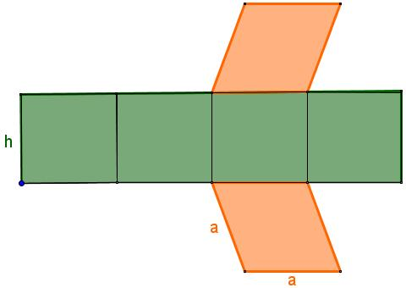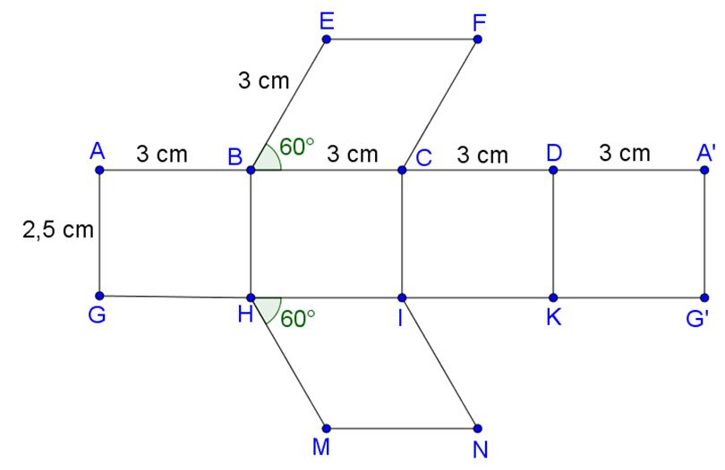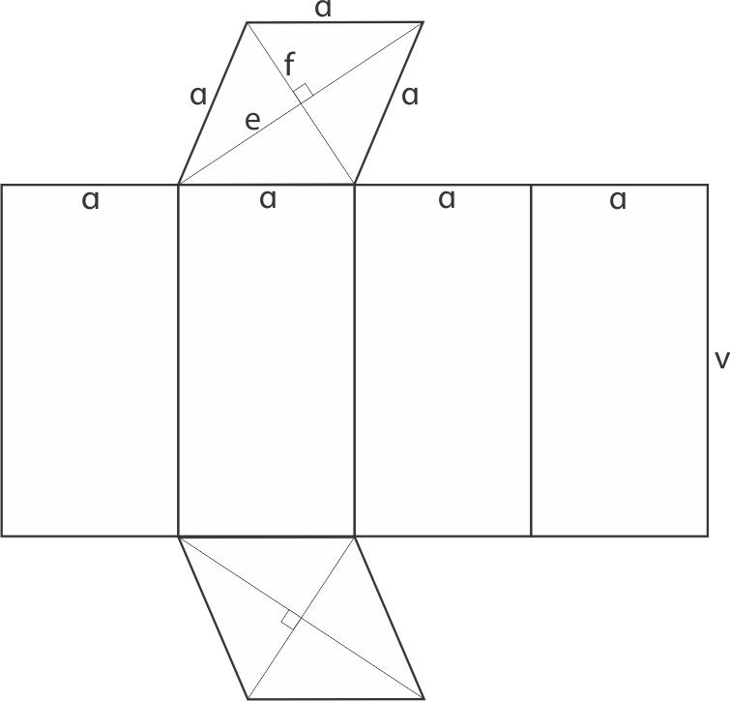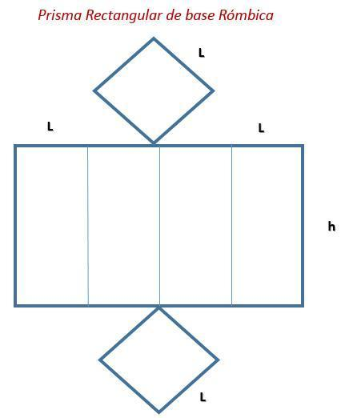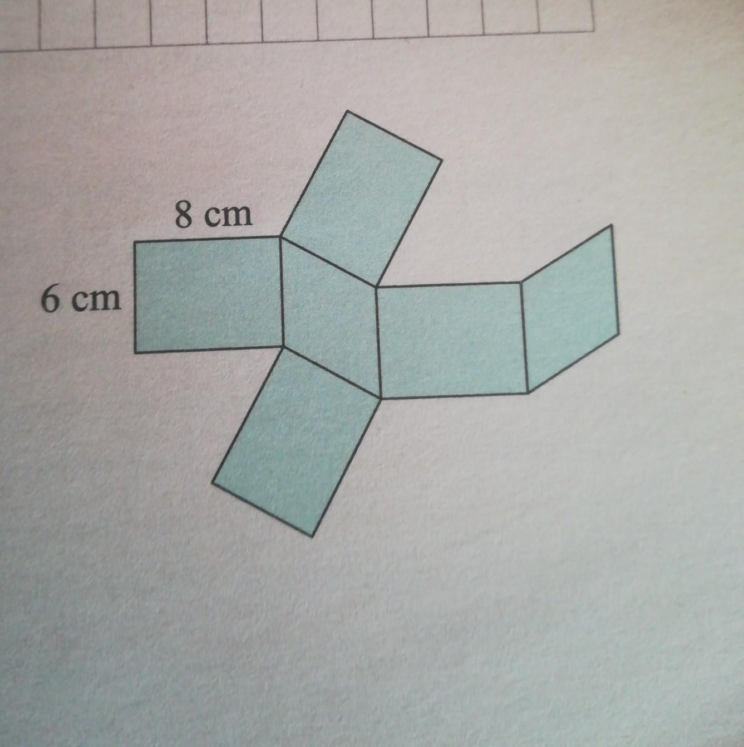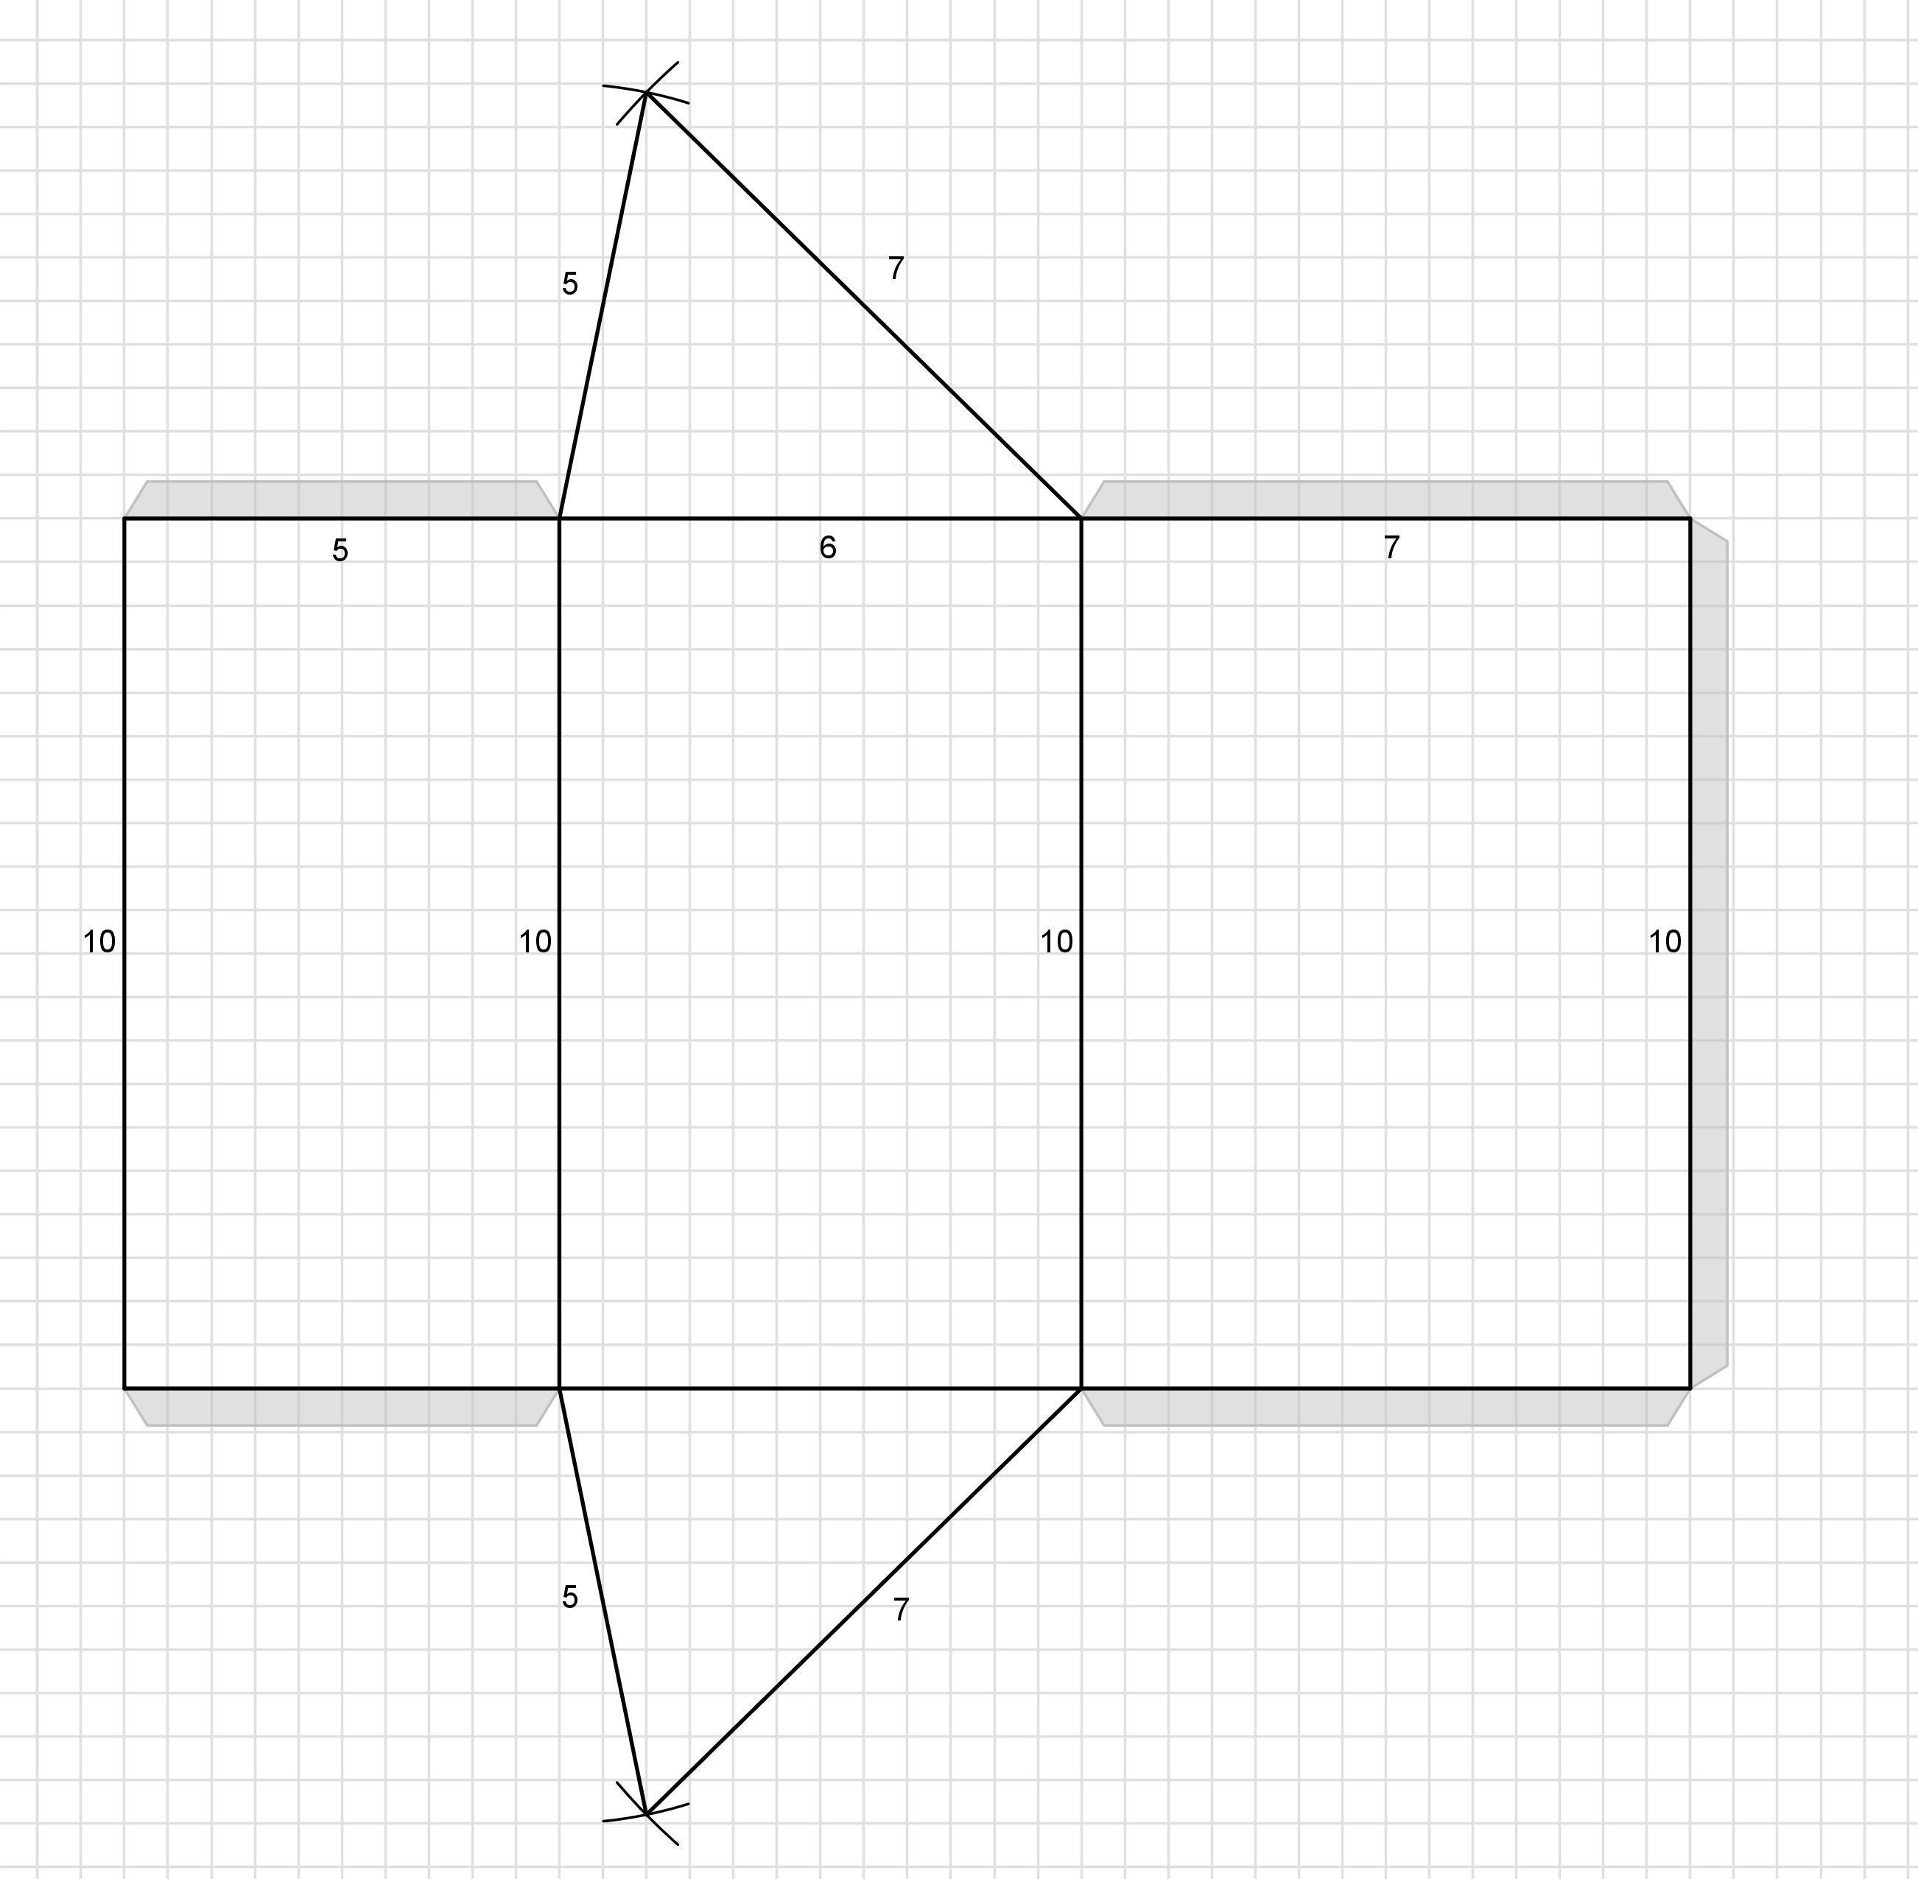

Applications
# Source: AI Source: Provided by: [Data Path: Persons Table -> ID Column: 1, Name_En Column: Motasem Essam] -> From: [ChatGPT] on [7/25/2026]
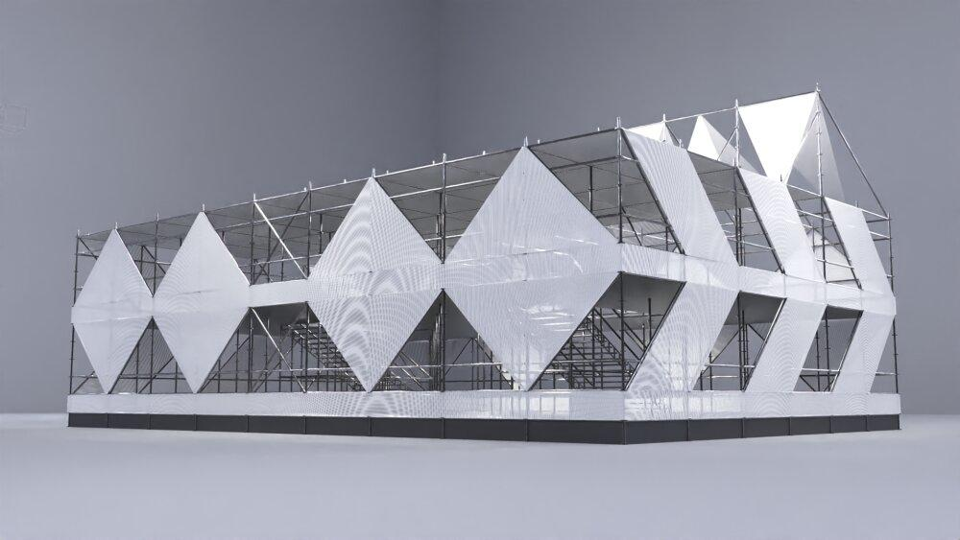
Architecture and design
Rhombic-prism geometry can help describe decorative structures, faceted forms, and architectural models.
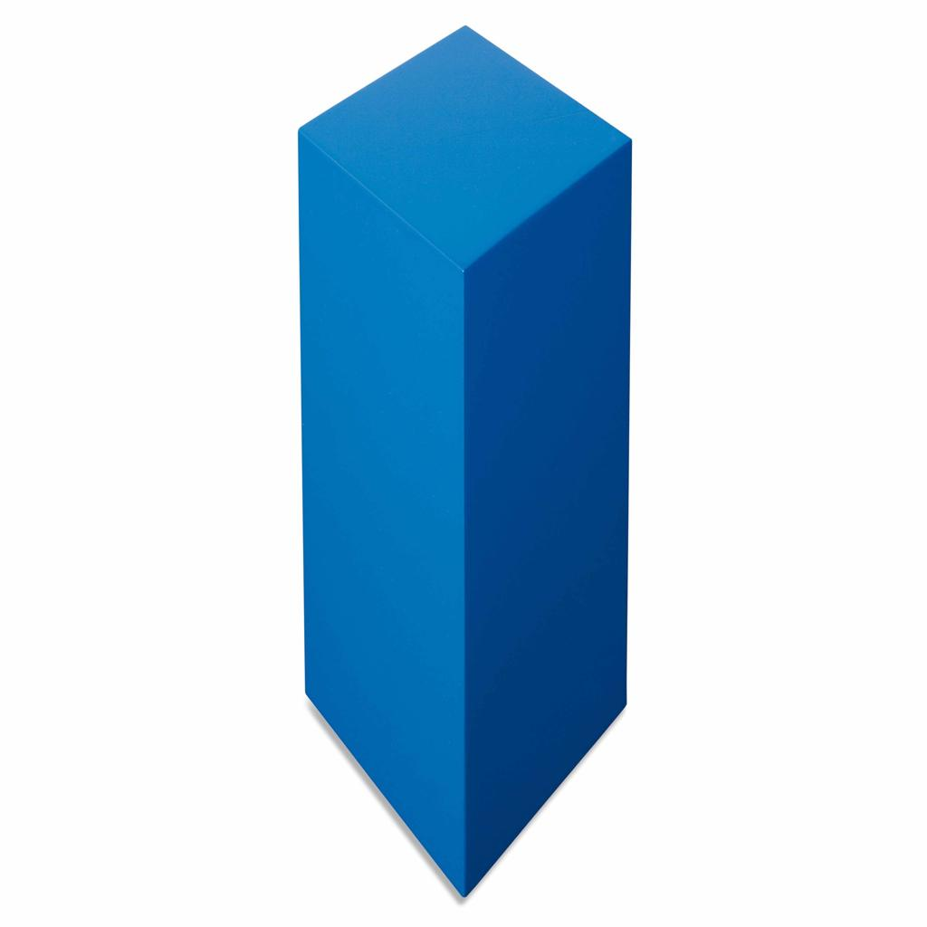
Mathematics education
It helps students study prisms, quadrilaterals, diagonals, surface area, volume, and Euler’s formula.
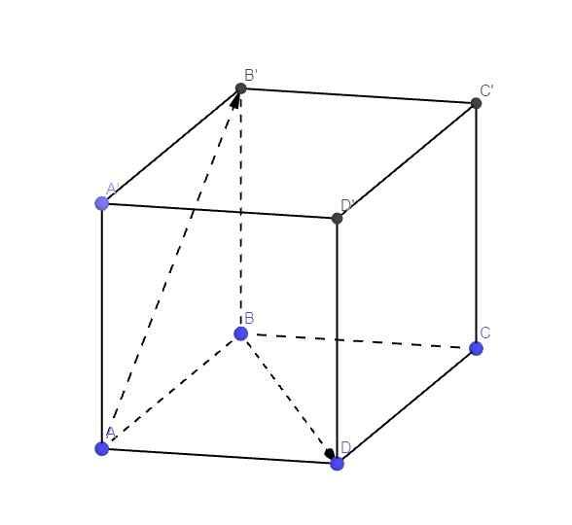
Engineering and 3D modeling
Its geometric properties are useful when constructing or analyzing solids with parallelogram-shaped side faces and rhombus-shaped ends.

Key Points
# Source: AI Source: Provided by: [Data Path: Persons Table -> ID Column: 1, Name_En Column: Motasem Essam] -> From: [ChatGPT] on [7/25/2026]
- A rhombus-base prism has two congruent, parallel rhombus bases.
- It has 6 faces, 12 edges, and 8 vertices.
- Each base has four equal sides, and its diagonals bisect each other at right angles.
- The volume is $V=Bh$, where $h$ is the perpendicular distance between the bases.
- For a right rhombus-base prism, the lateral surface area is $A_{L}=4ah$.
- A square-base prism is a special case of a rhombus-base prism.
- An oblique prism's lateral surface area must be calculated from its individual lateral faces.

Conclusion
# Source: AI Source: Provided by: [Data Path: Persons Table -> ID Column: 1, Name_En Column: Motasem Essam] -> From: [ChatGPT] on [7/25/2026]
A rhombus-base prism is a quadrilateral prism distinguished by its rhombus-shaped bases. Its geometry combines the properties of a rhombus with the three-dimensional structure of a prism. Understanding its faces, edges, vertices, diagonals, surface areas, and volume makes it easier to classify and analyze quadrilateral prisms. The distinction between right and oblique prisms is especially important when calculating lateral surface area.

